Leaving Cert Physics Worked Solutions 2022 Deferred exam

1.
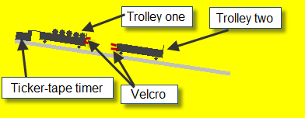
- Draw a labelled diagram of the experimental arrangement that the student could have used.
runway/air‐track with two trolleys/riders
means of getting trolleys to stick to each other, e.g. velcro or pin and cork
means of measuring distance and time, e.g ticker tape and ticker-tape timer OR cards and light gates

- Describe how the student could have made these measurements.
description of how distance was determined
Distance corresponds to distance between 11 dots.
description of how time was determined
The interval between two dots corresponds to 1/50th (0.02)of a second
Take 11 dots (corresponding to 0.2 seconds)

Velocity = distance divided by time

- What additional steps could the student have taken in order to make these measurements more accurate?
clean the track to minimise friction, tilt the track slightly to offset friction etc.
- Why should body A be moving with a constant velocity before the collision?
So that the velocity measured is the impact velocity / so its velocity on impact is known
- How did the student check this?
Check that the distance between dots is constant.
OR
Measure the initial velocity of body A twice [e.g. by comparing different sections of the tape]
- What velocity would you expect body A to have had before the collision?
The mass of body A was twice that of body B. So mass_{A} = 2 mass_{B}
total momentum before collision = total momentum after collision.
m₁u₁ + m₂u₂ = m₁v₁ + m₂v₂
Body B is at rest before collision and both bodies move off together with a common velocity v3 afterwards:
m_{A}u₁ + 0 = (m_{A}+m_{B})(v₃)

But m_{A} = 2 m_{B} so total mass afterwards = 3 m_{A}

m_{A}u₁ = (3m_{A})(v₃) u₁ = (3)(v₃)

v₃ = 0.18 m s^{–1} u₁ = (3)(0.18) = 0.54

- p = mv = 3 × 0.18 = 0.54 kg m s⁻¹
0.54 ÷ 2 = 0.27 m s^{–1}

2.
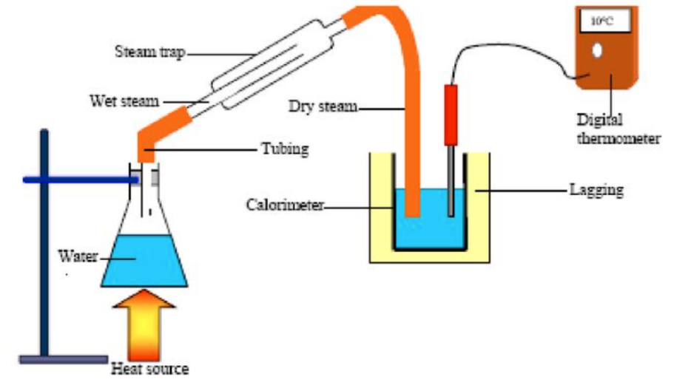
- Draw a labelled diagram of the apparatus that the student could have used in the experiment.
See diagram

Calculate the specific latent heat of vaporisation of water.
m_{water} = (75.3 -25.6) = 49.7 g m_{steam} = (76.6 – 75.3) == 1.3 g
Δθ_{water} = (26 – 12) = 14 °C Δθ_{steam} = (100 – 26) = 74 °C
(ml)steam + (mcΔθ)condensed_steam = (mcΔθ)cal ₊ (mcΔθ)water
(1.3 × l_{v}) + (1.3 × 4180 × 74) = (25.6 × 910 × 14) + (49.7 × 4180 ×14)
l_{v} = 2.18 × 10⁶ J kg^{–1}
- Why did the student use water that that had been cooled to below room temperature?
So that heat gained from the environment while the system was below room temp would cancel out the heat lost to th environment while the system was above room temperature. lost ≈ heat gained
- Discuss one advantage and one disadvantage of using a greater mass of steam.
advantage: A greater mass of steam would result in less % error in measuring the mass of steam but would also result in a greater change in temperature for the water therefore less % error in determining the change in temperature.
disadvantage: More heat lost to surroundings

3.
- What is meant by the focal length of a concave mirror?
Distance from the focal point/focus to the [back of] the mirror

- How did the student find an approximate value for the focal length?
He focused the image of a distant object onto a screen. Then measured the distance from mirror to screen.

- Why did the student find an approximate value for the focal length?
to make sure the object was not placed inside the focal length because to do so would mean no image could be formed on the screen.

- Describe how the position of the image was determined.
move screen/mirror/object until sharpest image is formed
- Use the data in the table to calculate the focal length.
1/u + 1/v = 1/f
one value calculated for f
Average f calculated

- Sketch the shape of a converging lens.
correct shape

- How does the arrangement of the apparatus differ between the two experiments? screen is on the same side of the mirror as the object
screen is on the other side of the lens as the object

4.
- What is meant by the word “monochromatic”?
one colour/wavelength/frequency

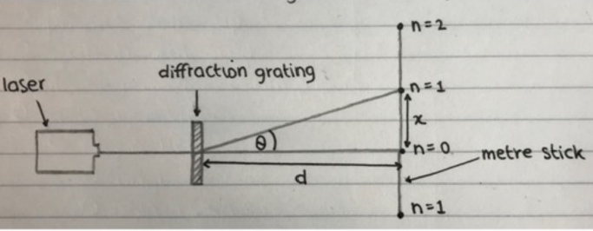
- Describe how the apparatus was arranged in this experiment.
See diagam
diffraction grating
screen
correct arrangement

- Explain how the value of d was determined.
From the diffraction grating note the value of n; this corresponds to the number of lines per mm.
Multiply by 1000 to get the number of lines per metre then use d= $\frac{1}{number of lines per metre}$

- Explain how the value of θ for each image, was determined.
Use meter stick to measure x and D.
Using trigonometry $\tan{θ=\frac{x}{D}}$

- Why would the student have wanted this?
Less % error associated with measurement of the angle.

- State one way in which the student could have achieved a larger angular separation of the images
move grating and screen further apart OR decrease d by using a grating with more lines per mm.

- If the grating being used had 400 lines per mm, calculate the wavelength of the light.
$d=\frac{1}{400000}$ = 2.5 × 10⁻⁶ m n = 3 θ = 50

nλ = dsinθ
3λ = (2.5 × 10⁻⁶) × sin 50
λ = 6.38 × 10^{–7} m

- Draw a diagram of what is observed when a beam of white light is passed through a diffraction grating.
Instead of a series of dots we get a series of spectra (red diffracted the most in each case) apart from straight through where instead we get a white light image.

5.

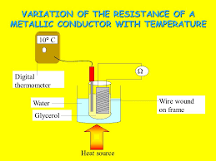
- Draw a labelled diagram of the experimental arrangement used and describe how the data in the table were obtained.
See diagram
Note the temperature by reading the thermometer.
Note the resistance by reading the ohmmeter.
Heat the water and glycerol to get different sets of readings.

- Use the table to draw a suitable graph that shows the relationship between the resistance of the conductor and its temperature.
labelled axes
points plotted
straight line of best fit
- Describe the relationship between resistance and temperature shown by your graph.
slope formula
resistance increases linearly with temperature
- Use your graph to find the rate of change of resistance with respect to temperature for the metallic conductor.
If resistance is on the vertical axis then the rate of change of resistance with respect to temperature corresponds to the slope of the graph. So use any two points to get:
dR/dθ ≈ 0.047 Ω C^{–1}

- Estimate the resistance of the metallic conductor when its temperature is –10 °C.
R ≈ 6.7 Ω / answer consistent with graph

- How would the results of the two experiments differ?
Resistance decreases for a thermistor
Non‐linear relationship for a thermistor

2022 Question 6
An athlete weighing 850 N runs up a stairs in 6 seconds. If the vertical height of the stairs is 2.5 m, calculate the average power generated by the athlete. | F = 850 N s = 2.5 m t = 6 s  $power=\frac{work}{time}= \frac{Fs}{t}=\frac{\left(850\right)\left(2.5\right)}{6}$ = 354 W  Alternatively you could have used W = mgh instead of W = Fs
State Archimedes’ principle. | When an object is immersed in a fluid the upthrust it experiences is equal to the weight of displaced fluid.
Calculate the length of a pendulum that has a period of one second. | $T=2π\sqrt{\frac{l}{g}}$ $T^{2}=\frac{4π^{2}l}{g}$ $l=\frac{gT^{2}}{4π^{2}}$ $l=\frac{(9.8)(1)}{4π^{2}}$ l = 0.248 m
A thermocouple thermometer and an alcohol‐in‐glass thermometer each gave a different reading when placed in the same container of water. Explain why this occurred. | Because different thermometric properties do not change proportionally with change in hotness.
A standing wave is set up in a stretched string that is fixed at each end. Sketch the first two harmonics that are produced when the string is plucked. | 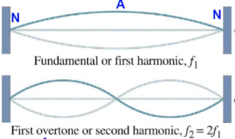
What is meant by sound intensity? | Sound intensity corresponds to power unit area  OR rate of change of energy per unit area
Calculate the effective focal length of two thin lenses in contact, one a converging lens of focal length 5 cm and the other a diverging lens of focal length 15 cm. | f₁ = 5 cm f₂ = –15 cm  $\frac{1}{f_{total}}=\frac{1}{f_{1}}+\frac{1}{f_{2}}$ $\frac{1}{f_{total}}=\frac{1}{5}+\frac{1}{-15}$  f_{total} = 7.5 cm
A precaution usually taken when using electrical equipment is to put a fuse in the circuit. Explain the role of a fuse. | The fuse is a deliberate weak link which melts and therefore breaks the circuit when current is too high
A solid copper cube of side 5 cm rests on a horizontal table.  Find the pressure exerted by the cube on the table.  density of copper = 8960 kg m⁻³ | First we need to calculate the mass of the object. We can do this by noting that $density=\frac{mass}{volume}$  Mass = density × volume  Density = 8960 kg m⁻³ volume = (0.05)³ Mass = (8960) × (0.05)³ = 1.12 kg  $presure={\frac{force}{area}=\frac{mg}{area}= \frac{(1.12)(9.8)}{{(0.05)}^{2}}}^{}$  = 4390.4 Pa
What is meant by the U‐value of a material? | Rate of energy transfer through 1 m² of a surface each second when a temperature difference of 1 K across the surface.
How are X‐rays produced? | High speed electrons hit a metal. Some electrons inside the atoms of the metal absorb this energy and jump up to a higher level (‘excited state’). When they fall back down the energy is emitted as X-rays.
Name the metal used as a target in the Cockroft and Walton experiment. | lithium

2022 Question 7
- Define displacement.
distance in a given direction

- Define velocity.
rate of change of displacement with respect to time

- What is a vector quantity?
a quantity with magnitude and direction

- What is the resultant velocity of the swimmer?
magnitude: √((2.5) + + (4)2 = 4.72 m s^{–1}
direction: tan^{–1} (4/2.5) = 58° [3]

- How long will it take the swimmer to reach the opposite bank of the river?
t = s/v = 75/2.5 = 30 s
- What will be the displacement of the swimmer from his starting position when he has reached the opposite bank?
s = vt
s = 4.72 × 30 = 141.6m

- Describe a laboratory experiment to find the resultant of two co‐planar forces.
application of two known or measureable forces
application of third known or measureable force to counteract first two forces
lines drawn to indicate magnitude and direction of the forces
find the resultant of the first two forces
- If the frictional force on the car as it moves down the slope is a constant 550 N, calculate the acceleration of the car.
Wsin10° = mgsin10° = (1000)(9.8)( sin10°)= 1702 N
F = 1702 – 550 = 1152 N
F = ma
a = 1152 ÷ 1000 = 1.152 m s⁻²

2022 Question 8
- What is the Doppler effect?
It is the apparent change in frequency of the wave due to the relative motion between the source and the observer.
- Explain how the Doppler effect occurs.
as source moves towards observer // as source moves away from observer
shorter λ // longer λ
increased f // decreased f

- What is meant by the emission line spectrum of an element?
specific frequencies of e.m. radiation emitted by an element
- How is the emission line spectrum of an element related to the energy levels of the electrons in an atom of that element?
Electron moves to a higher level (when given energy)
Electron falls to a lower level
E₂ – E₁ = hf
- Describe how you would show the emission line spectrum of hydrogen in the laboratory.
hydrogen vapour lamp [with energy source, e.g. electric current]
diffraction grating / prism
- Calculate its frequency.
c =fλ
f = (3 × 10⁸) ÷ (656 × 10^{–9}) = 4.57 × 10¹⁴ Hz

- Calculate the frequency they observed.
f’ = cf/(c ± u)
substitution
f’ = 4.15 × 10¹⁴ Hz

- Use this data to calculate a value for the radius of the orbit of the Sun about the centre of
the galaxy.
T = 2π/ω
T = 7.57 × 10¹⁵ s
v = rω
r = 2.65 × 10²⁰ m

2022 Question 9
- State Faraday’s law of electromagnetic induction.
emf induced is proportional to the rate of change of [magnetic] flux

- State Lenz’s law. of electromagnetic induction.
the direction of the induced current/emf is such that it opposes the change which caused it
- Describe how you would demonstrate each of these laws in the laboratory.
means of changing magnetic flux
means of measuring induced emf
correct observation
suitable apparatus
correct observation
- Calculate the magnetic flux through the coil.
Φ = BA
Φ = (1.5 × 10–3) × (0.2)2 = 6 × 10–5 Wb

- If the speed at which the coil is moved is 2.5 m s^{–1}, calculate the emf induced in the coil.
emf = –N(dΦ/dt)
t = s/v = 0.2/2.5= 0.08 s
emf = 4 × (6 × 10–5/0.08) = 0.003 V

- What happens in coil B when an alternating voltage is applied to coil A?
voltage/current
- What is the purpose of a transformer?
to change the (size of an alternating) voltage
- Describe the principle of operation of a transformer.
alternating voltage in primary coil
changing magnetic field (induced in core)
[alternating] voltage induced in secondary coil

2022 Question 10
(a)
- Explain, with the aid of a labelled diagram, the operation of a cathode ray tube.
cathode and anode
cathode heated
emission of electrons at cathode
application of electric/magnetic field (to change direction of electron beam)
screen

- State two of the disadvantages of cathode ray tubes that led to their replacement by flat‐screen displays.
Heat loss, size etc.

(b)
- What information does the photoelectric effect give about the nature of light?
quantised/photonic nature of light
- What effect does the frequency of the incident light have on the current flowing in a photocell?
no current flows if frequency is below a certain (threshold) frequency
- Describe how you would show this effect in the laboratory.
e.m. radiation source of varying frequency (incident on photocell)
ammeter/galvanometer
change in current detected
- What effect does the intensity of the incident light have on the current flowing in a photocell?
current increases with intensity [above threshold frequency]
- Describe how you would show this effect in the laboratory.
e.m. radiation source of varying intensity (e.g. distance incident on photocell)
ammeter/galvanometer
change in current detected
- Calculate the energy of a photon of the incident light.
E = hf
E = (6.6 × 10^{–34}) × (7.6 × 10¹⁴) = 5.04 × 10^{–19} J

- Calculate the energy of the most energetic electron emitted.
Φ = 2.1 eV = 3.36 × 10^{–19} J
E = 5.04 × 10–19 – 3.36 × 10^{–19} = 1.68 × 10^{–19} J

2022 Question 11
- Define potential difference.
The potential difference between two points is the work done when a charge of 1 coulomb moves from one point to the other.

- Define resistance.
Resistance is defined as the ratio of voltage to current.
- Derivation
For currents in parallel I_{Total} = I₁ + I₂
But $I=\frac{ V}{R}$ ⇒ $\frac{V_{T}}{R_{Total}}= \frac{V_{1}}{R_{1}}+ \frac{V_{2}}{R_{2}}$ cancel the V’s ⇒ $\frac{1}{R_{Total}}= \frac{1}{R_{1}}+ \frac{1}{R_{2}}$

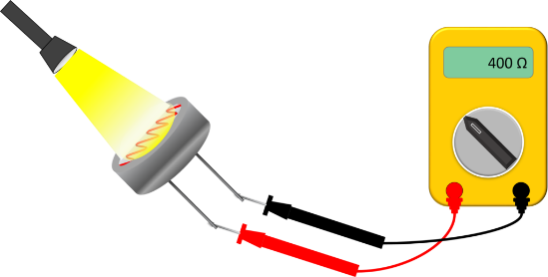
- Describe an experiment to show how the resistance of an LDR varies with the intensity of the light falling on it.
- Set up as shown. Set the multimeter to read resistance.
- Move the torch farther away from the light dependent resistor (LDR).
- Note that the resistance goes up as the light intensity goes down.

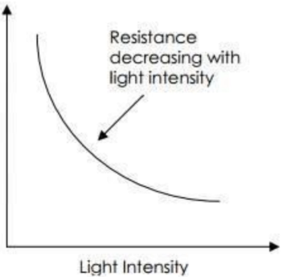
- Sketch a graph to show the relationship between the resistance of an LDR and the intensity of the light falling on it.
labelled axes
correct shape

- Calculate the total resistance of the circuit.
For resistors in parallel: $\frac{1}{R_{Total}}= \frac{1}{R_{1}}+ \frac{1}{R_{2}}$ $\frac{1}{R_{Total}}= \frac{1}{1100}+ \frac{1}{900}$ R_{total} = 495 Ω

Total resistance in circuit = 495 + 500 = 995 Ω
- Calculate the current flowing through the 900 Ω resistor.
Total current in the circuit: Use I = V ÷ R I = 12 ÷ 995 = 0.012 A
Voltage across 500 Ω resistor: Use V = RI V = (500)(0.012) = 6V
Voltage across the 1100 Ω and 900 Ω resistors: 12 – 6 = 6 V
Current flowing through the 900 Ω resistor: Use I = V ÷ R I = 6 ÷ 900 = 0.0066 A
- Explain what happens to the potential difference across the 500 Ω resistor.
Resistance of the LDR decreases, therefore potential difference across the parallel section decreases. Total potential still has to add up to 12 V so potential difference across 500 Ω resistor increases.
If you’re not sure about this then repeat the calculation above using a 1000 Ω instead of 1100 Ω

2022 Question 12
Explain what is meant by the following terms:
- Quark: fundamental particle/found in hadrons /feels strong force
- Lepton: fundamental particle does/not feel strong force
- Meson: quark anti‐quark pair
- Baryon: three quarks

- State the quark composition of the proton and the neutron.
proton: up up down neutron: up down down
- Why is it that the pi meson that is formed in the collision must be neutral?
So that charge is conserved
- Assuming that the pi meson produced has a negligible speed, and that both protons have an equal speed of v after the collision, calculate v.
this is the only time where we had to consider that the protons have kinetic energy after the collision. The new particle is a pi meson and we are told that it has negligible speed so we can discount any kinetic energy term there. The equation to represent this collision therefore becomes:
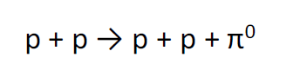

Before collision | After collision
$p^{+}$ + $p^{+}$ + kinetic energy of protons before collision | $p^{+}$ + $p^{+}$ + kinetic energy of protons after collision + π⁰

Therefore the problem reduces to the following:

kinetic energy of protons beforehand = kinetic energy of the protons afterward plus one pi meson

½ mv₁² + ½ mv₁² = ½ mv₂² + ½ mv₂² + m_{pi meson}c²

mass of proton | 1.67 × 10^{–27} kg
v₁ = speed of protons before collision | 1.5 × 10⁸ m s⁻¹  (we were told that the speed of the protons before collision is half the speed of light)
Kinetic energy of two protons before collision | (2)[(½)( 1.67 × 10^{–27})(1.5 × 10⁸)²]
Mass of pion (m_{π}) | (264)(m_{electron}) = (264)(9.1 × 10^{–31}) = 2.4 × 10^{–28} kg
Energy associated with creating a pion | (m_{π})(c²)  = (2.4 × 10^{–28})(3.0 × 10⁸)² = 2.16 × 10^{–11} J

½ mv₁² + ½ mv₁² = ½ mv₂² + ½ mv₂² + m_{pi meson}c²

(2)[(½)( 1.67 × 10^{–27})(1.5 × 10⁸)²] = (2)[(½ mv₂²) + m_{pi meson}c²

(1.67 × 10^{–27})(1.5 × 10⁸)² = (1.67 × 10^{–27})v₂² + 2.16 × 10^{–11}

(1.67 × 10^{–27})(1.5 × 10⁸)² = (1.67 × 10^{–27})v₂² + 2.16 × 10^{–11}

v₂ = 9.8 × 10⁷ m s⁻¹
- Name the scientist who predicted the existence of anti‐matter.
Dirac

2022 Question 13

  - How do a.c. and d.c. differ?
a.c. changes direction while d.c is one direction only.
  - Calculate the power of the turbine when the wind speed increases to 15 m s^{–1}.
“power generation shoots up because it is governed by the cube of the airstream’s velocity.”
I can’t see many students getting this one. I had to refer to the marking scheme myself. What the sentence means is that the power generated is proportional to the cube of the velocity.
So the power increases by the same factor as the cube of the velocity
The velocity increased by a factor of 3.375 (15 ÷ 10)³ so
The
15 ÷ 10 = 1.5
1.5³ = 3.375
The power increases by this factor, so new power = (200 × 3.375) = 675 kW

  - Calculate the number of units of electrical energy generated by the turbine in that year.
The unit of electrical energy is the kilowatt hour which corresponds to the number of kilowatts multiplied by the number of hours.
1 year = 8760 hours so total number of kW hours = (300 × 8760) = 2628000 kW hours
  - Name the term used to describe this conversion.
rectification
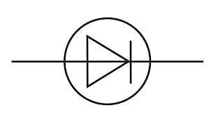
  - Draw the electrical circuit symbol for the semiconductor device used in this process.
See symbol for a diode

  - Calculate the rms voltage generated.
V_{rms} = V_{max} ÷ √2 = 690 ÷ √2 = 488 V
  - Calculate the rms current generated.
P = 1.5 MW = 1.5 × 10⁶ W
P = VI I = P ÷ V I = (1.5 × 10⁶) ÷ 488 = 3074 A
  - Explain why a very high voltage is required for the efficient transmission of electricity.
Hight voltage means low current
Low current means smaller loss in heat/energy
  - State one reason why an insulator is needed in the transmission of electricity.
It reduces the likelihood of electric shock.

2022 Question 14
14 (a)

- State Hooke’s law.
For a stretched string, force is proportional to displacement

- Calculate the elastic constant of the spring.
F = k(extension)
0.7 = k(0.06)
k = 11.7 N m^{–1}

- Calculate the period of the simple harmonic motion.
W = mg m = W ÷ g m = 0.7 ÷ g m = 0.0714 kg
$ω= \sqrt{\frac{k}{ m}}= \sqrt{\frac{11.7}{ 0.0714}}$= 12.8 $T= \frac{2π}{}= \frac{2π}{12.8}$ = 0.49 s
- maximum velocity: at the equilibrium position, i.e. 56 cm
- maximum acceleration: at a position of maximum amplitude

14 (b)

- State Snell’s law of refraction.
sin i is proportional to sin r

- Calculate the refractive index of the glass for blue light.
The diagram is set likely to cause confusion. The angle of incidence and the angle of refraction are all relative to the normal, so in this case angle of incidence = 40° and the angle of refraction is 25°,
n = sin i ÷ sin r = sin 40° ÷ sin 25° = 1.52
- Calculate the speed of this light in the glass.
Refractive index = $\frac{speed of light in air}{speed of light in glass}$ 1.52 = $\frac{3×{10}^{8}}{speed of light in medium}$

Speed of light in medium = 1.97 × 10⁸ m s⁻¹
- Calculate the wavelength of this light in the glass.
This is a tricky one. When light goes from one medium to another its speed changes, as does its wavelength but the frequency remains constant. No idea how you were to know that you needed to know this.
So we can rearrange the relationship c = f λ to give $f=\frac{c}{λ }$
$$f=\frac{c_{air}}{λ_{air}}=\frac{c_{glass}}{λ_{glass}}$$

c_{air} = 3 × 10⁸ m s⁻¹ λ_{air} = 480 nm = 480 × 10⁻⁹ m c_{glass} = 1.97 × 10⁸ m s⁻¹

$\frac{3 ×{10}^{8}}{480 ×{10}^{-9}} =\frac{1.97 ×{10}^{8}}{λ_{glass}}$ λ_{glass} = 315 × 10⁻⁹ m

- Explain why this is happens.
Each wavelength has a different refractive index so red light refracts at a different angle to blue light.

14 (c)

- What is a capacitor?
a device that stores charge / separates charge
- Define the unit of capacitance, i.e. the farad.
coulomb per volt
- Calculate the charge on plate A.
Q = (3 × 10^{–6}) × 6 = (+)1.8 × 10^{–5} C
- Calculate the charge on plate B.
Q = –1.8 × 10^{–5} C
- Calculate the energy stored in the capacitor.
E = ½CV² = 5.4 × 10^{–5} J

- Calculate the charge that is now on plate A.
[+]1.8 × 10^{–5} C
- Calculate the charge that is now on plate B.
–1.8 × 10^{–5} C
- Calculate the charge that is now on plate X.
[+]1.2 × 10^{–5} C
- Calculate the charge that is now on plate Y.
[-]1.2 × 10^{–5} C
- Calculate the capacitance of a single capacitor
Q = 3 × 10^{–5} C
5 µF

14 (d)

- What is meant by nuclear fission?
the splitting of a large nucleus into two smaller nuclei [with the release of neutrons/energy]
- Is this a spontaneous nuclear reaction or an induced nuclear reaction?
induced
- What numbers or symbols do X, Y and Z represent in the above equation?
X = 36
Y = n
Z = Ba

- Calculate the number of atoms of krypton–89 in a sample of the isotope that emits 2.0 × 10⁵ beta particles per second.
A = λN
N = (2.0 × 10⁵ ÷ (3.67 × 10^{–3}) = 5.45 × 10⁷ atoms

- What is the half‐life of krypton–89?
T½ = (ln 2)/λ
T½ = 188.9 s

